Chapter-6: Testing

# 6.1 Introduction

Testing is the process or activity that checks the functionality and correctness of software according to specified user requirements to improve the quality and reliability of the system.

We do three types of testing in this system.

* Unit Testing
* Integration Testing
* System Testing

**6.2 Unit Testing**

Also known as Program Testing, it is a type of testing where the analyst tests or focuses on each program or module independently. It is carried out to execute each statement of the module at least once. Unit Testing is typically performed by the developer. It is a testing method using which every independent module is tested to determine if there are any issues by the developer himself.

* In unit testing, the accuracy of a program cannot be assured and it is difficult to conduct testing of various input combinations in detail.
* It identifies maximum errors in a program as compared to other testing techniques.

Here is the example of unit testing of this system:

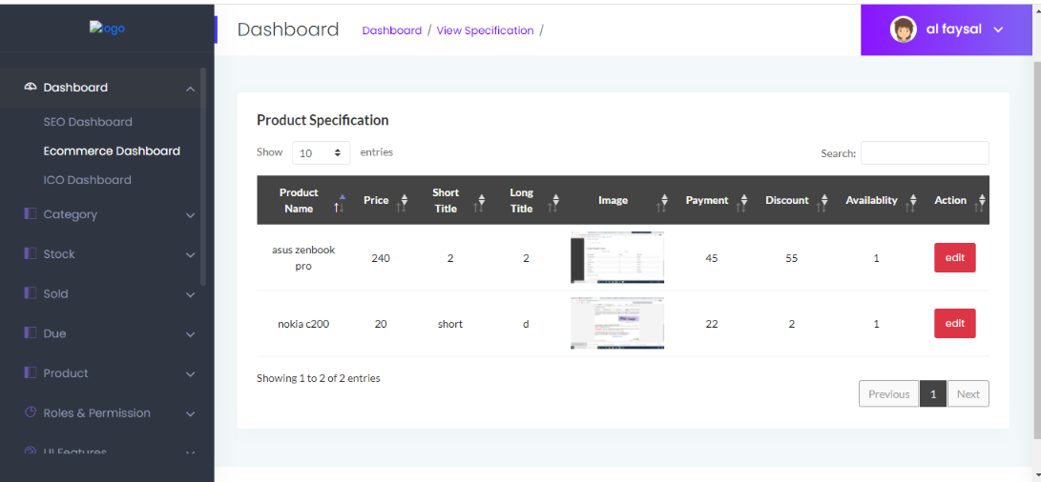

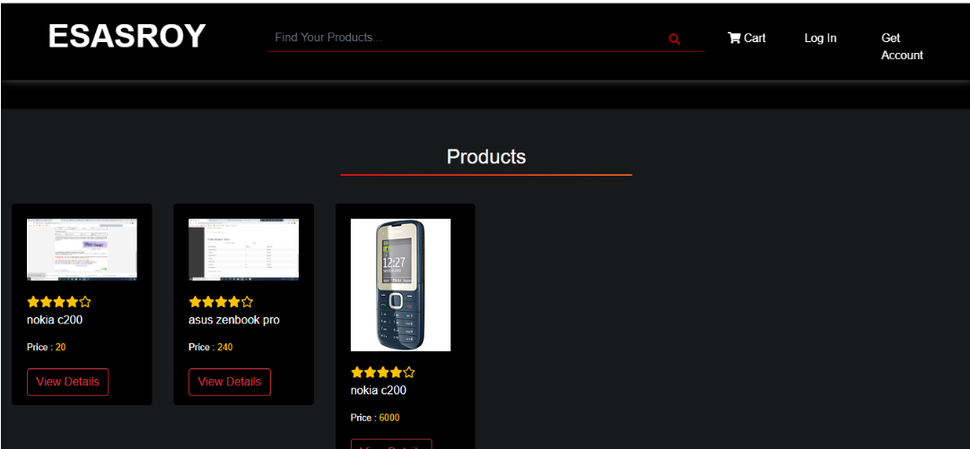

Here, we upload specifications about a product and we get the information as we wanted.

**6.3 Integration Testing**

In Integration Testing, the analyst tests multiple modules working together. It is used to find discrepancies between the system and its original objective, current specifications, and systems documentation. Some benefit of Integration testing:

* Integration testing allows ensuring the appropriateness of the modules and their results.
* It also helps to detect the issues related to the interface between modules.
* Integration testing helps to stimulate the interaction between various modules.

Here is the example of integration testing of this system:

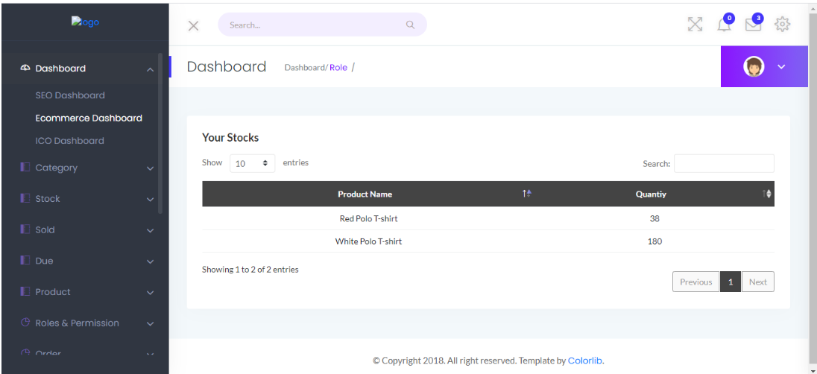

This is the Stock page for a shop. There are two products here, one is Red Polo shirt. The quantity of this product is 38.

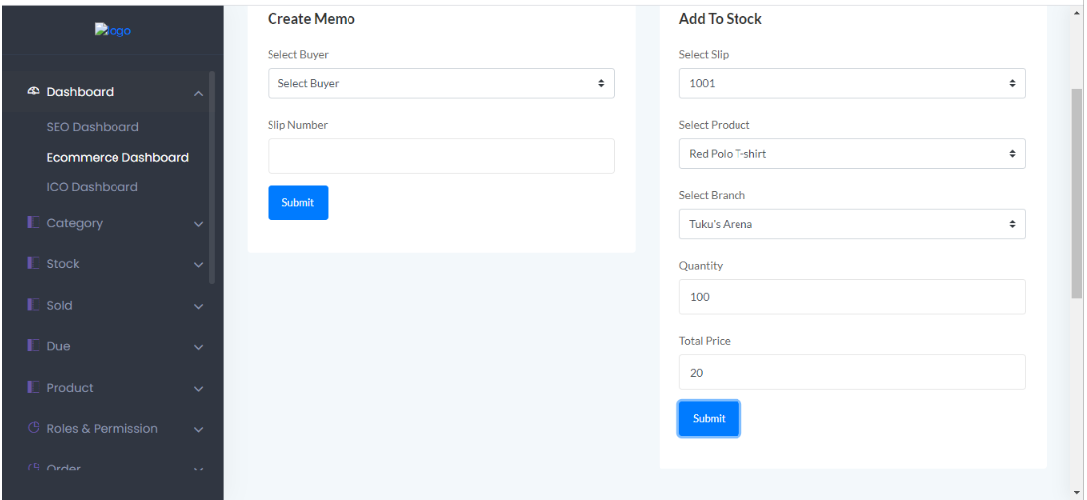

On this page, Business Super Admin or Business Admin create new stock. When a new set of products they buy, they upload that information through this page. Here, 100 Red Polo T-shirts they buy, and they upload that information in stock.

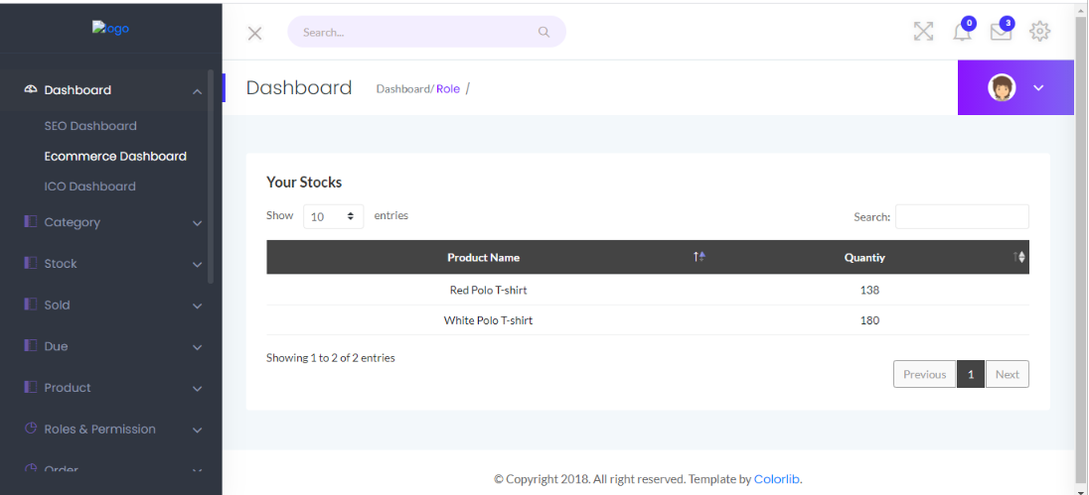

Here, 100 Red Polo T-shirts added in the stock.

This is first example of integration testing of this system. Here, stock management is shown, how a product added in the stoke.

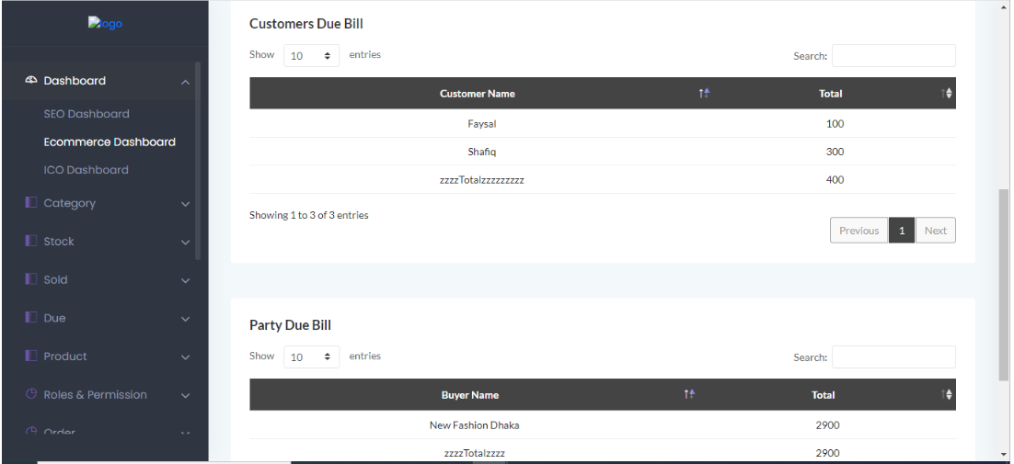

This is the customer due to the bill list. If one customer buys some product without payment at that time, that data will be shown on that page. Here, a customer named Faysal has 100 Taka due from his previous buy.

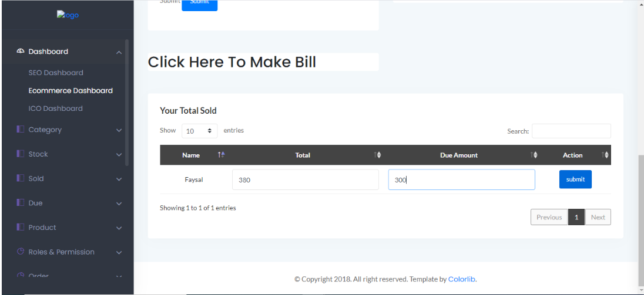

When a customer wants to buy some product, this is where Business Super Admin or Business Admin create a bill for this customer. Here a customer named Faysal buys some product and doesn't pay the full amount at that time. He has a due bill of 300 Taka.

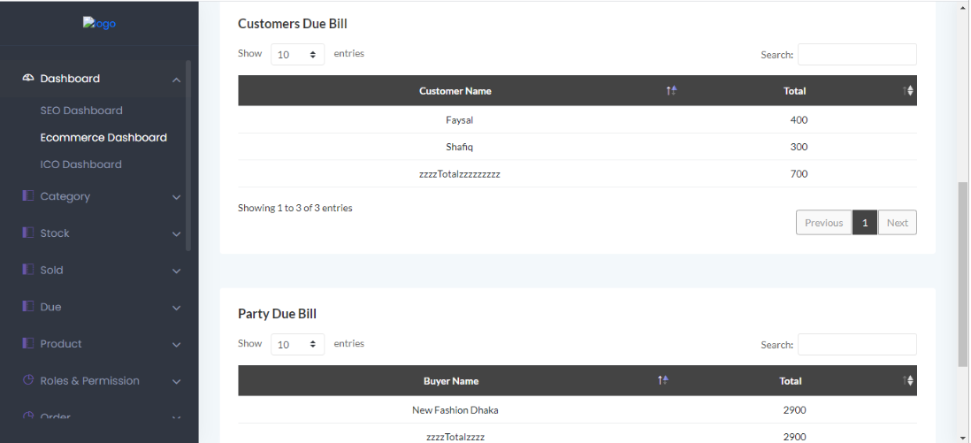

Faysal had 100 Taka due from his previous buy. After this shopping, Faysal has a total due bill is 400 Taka.

This is second example of integration testing of this system. Here, customer billing and due bill management is shown.

**6.4 System Testing**

System Testing is a type of testing that is performed on a complete integrated system to evaluate the compliance of the system with the corresponding requirements. In system testing, integration testing passed components are taken as input. The goal of integration testing is to detect any irregularity between the units that are integrated together. System testing detects defects within both the integrated units and the whole system. The result of system testing is the observed behavior of a component or a system when it is tested.